**Ms. Sondej’s students, please take a second to review your modifications.**

PLEASE REFER BACK AND FOLLOW DAY 1’S OUTLINE TO CHANGE YOUR LEVELS.
If you have any questions, please email me at: Esondej@gboe.org
_____________________________________________________________________________
Day 7 (March 24th, 2020):
First Subject: ELA (Language Arts and Reading)
Definitions/Vocab that you may need for ReadWorks article, “Leaping Lizards”:
Volunteer- is a person who does something, especially helping other people, willingly and without being forced or paid to do it.
Command- is an authoritative direction or instruction to do something. ; a demand.
Veterinarian- a person relating to, practicing, or being the science and art of prevention, cure, or alleviation of disease and injury in animals and especially domestic animals. ; a person qualified and authorized to practice veterinary medicine.
Theme/Main Idea- Also referred to as a main idea, a theme is the subject explored in a piece of writing. All literary works have a theme. It is what a piece of writing is about.
*Answer all questions directly on the “Packet”, if you’ve picked up the hard copies at school.*
*If you are doing them off of the computer because you DID NOT pick up your packet, you need to transfer your answers into a new notebook.*
For question #5, remember to use RACE when writing your answer!
Example for question #5: “I think the most interesting animal that came from this article
is ___________ because…”
** (Make sure that you explain WHY after you pick your most interesting animal.) **
(Make sure that you use evidence from the text to support your answer.)
______________________________________________________________________________
Second subject: MATH (Add and Subtract Fractions)
SEE “Adding and Subtracting Fractions” Charts Below:
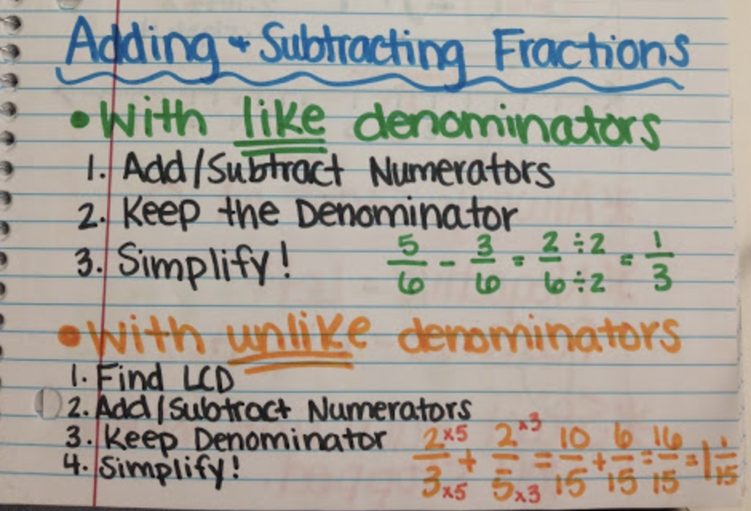
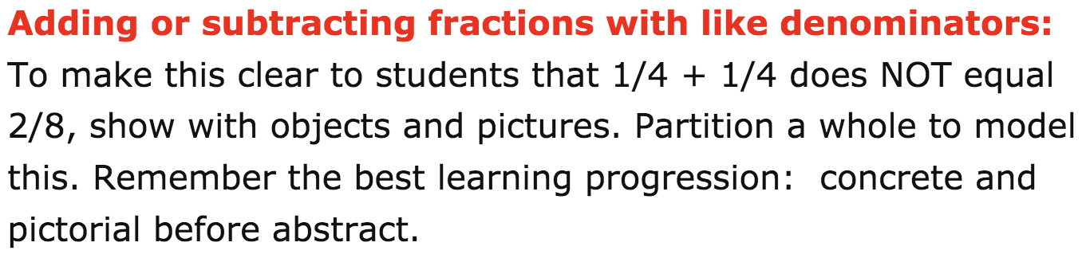
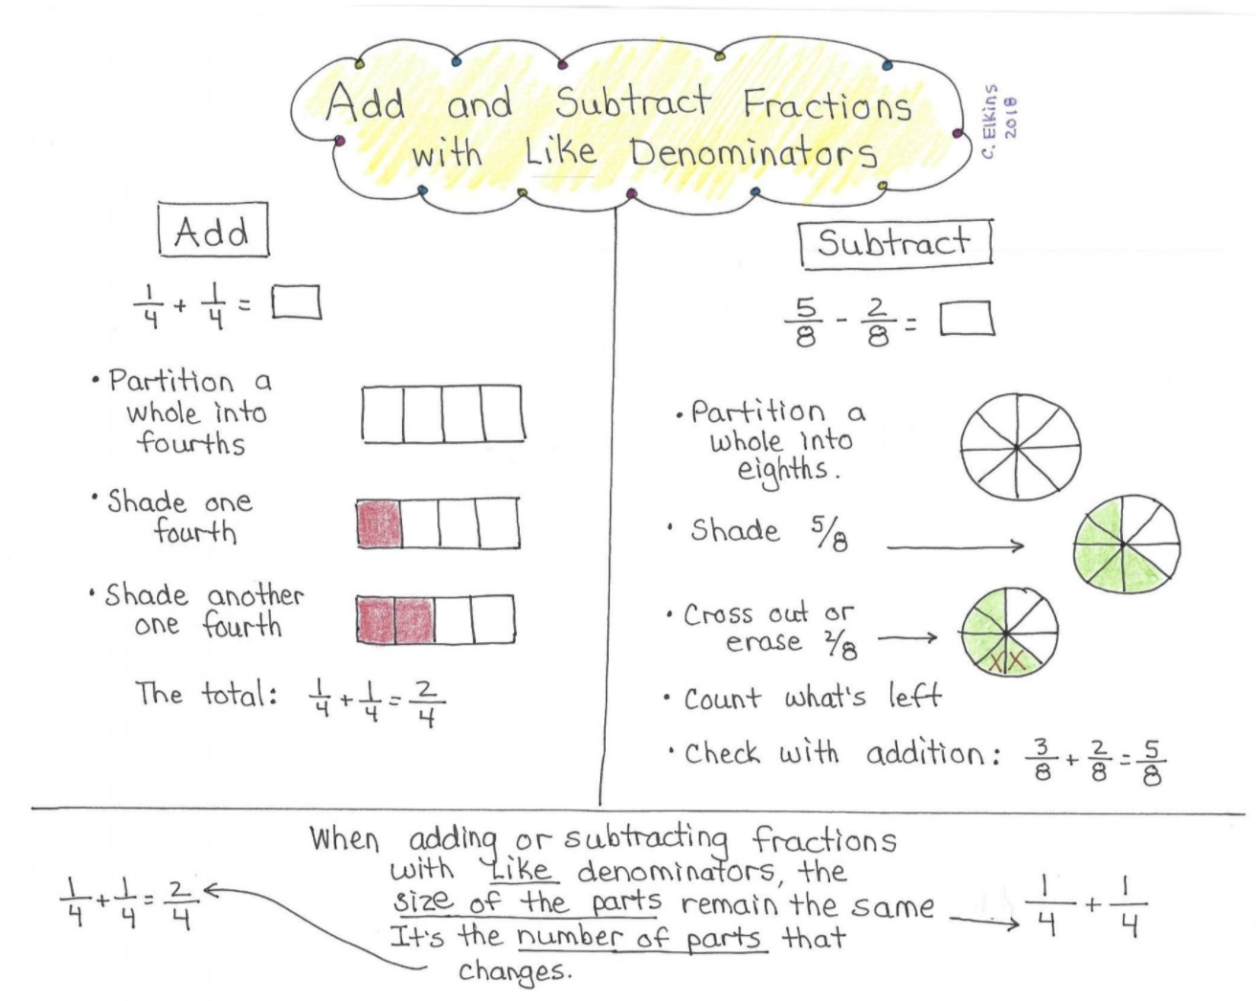_________________________________
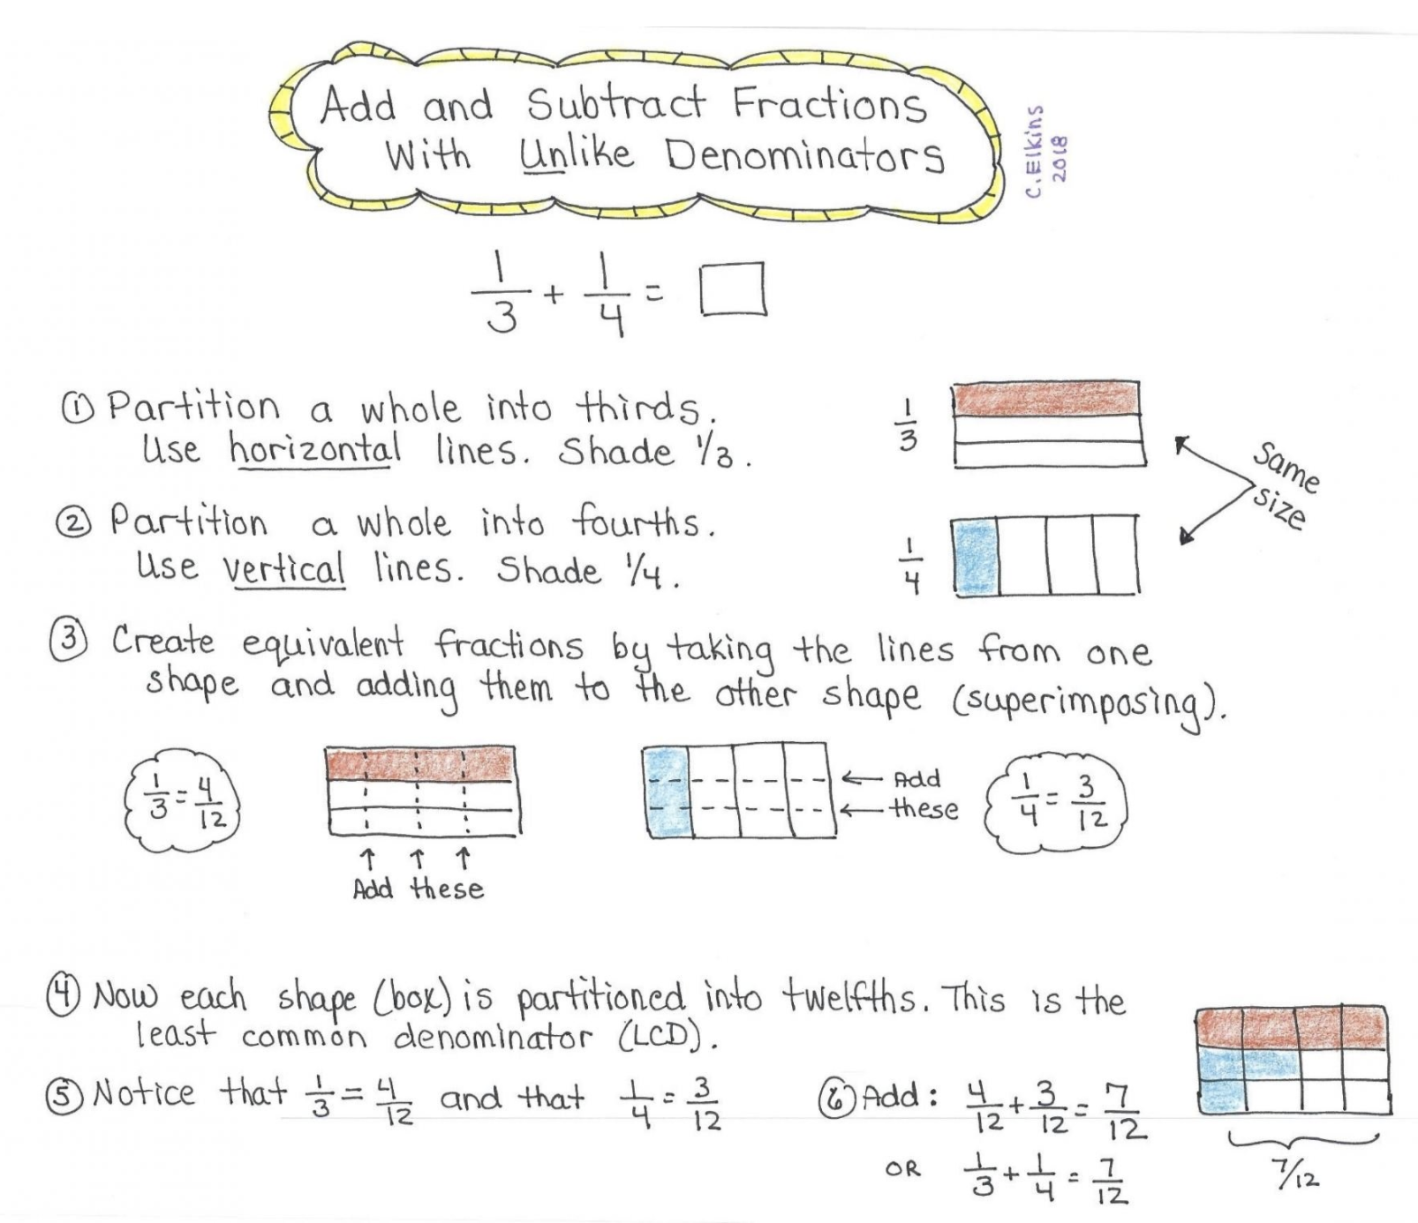
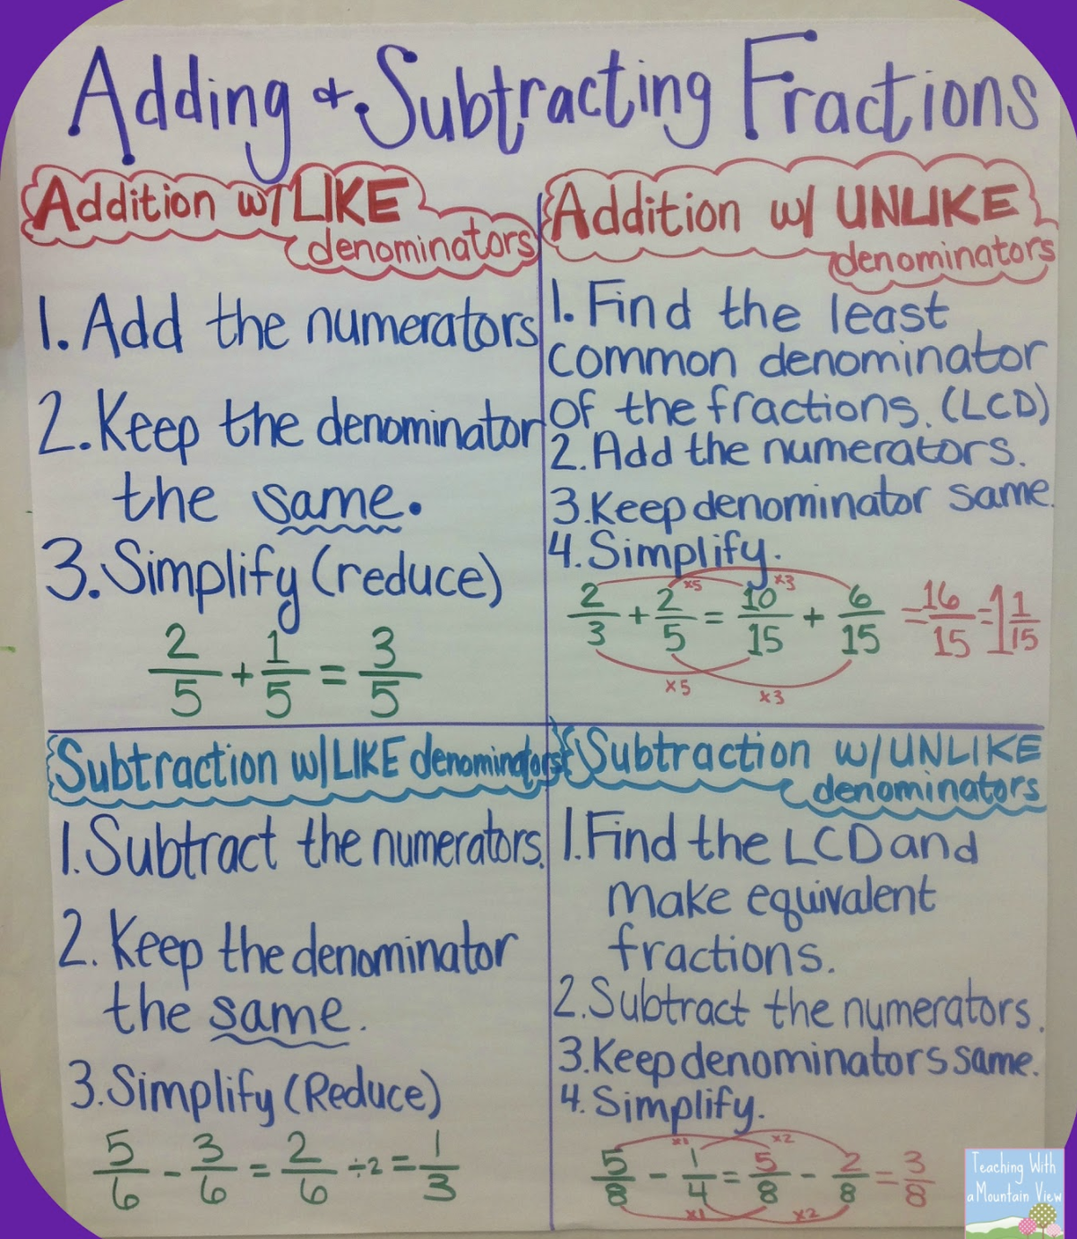

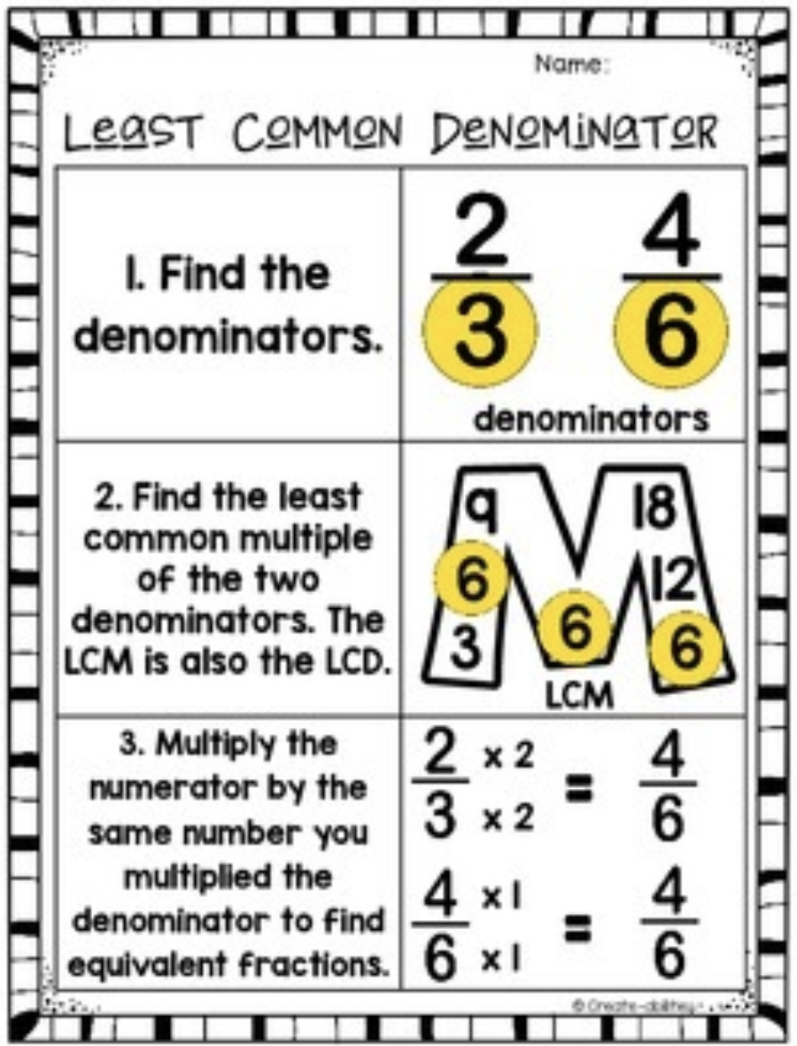
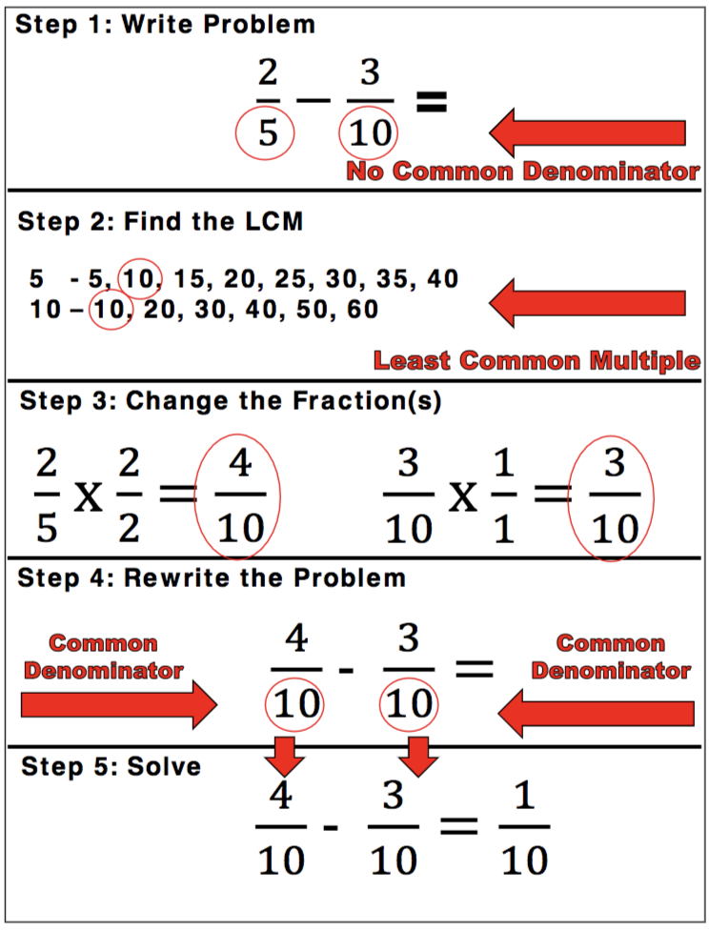
I’ve also included a mini-lesson on add and subtracting fractions as well, just in case you need a refresher. : )
(It’s on the next page below)
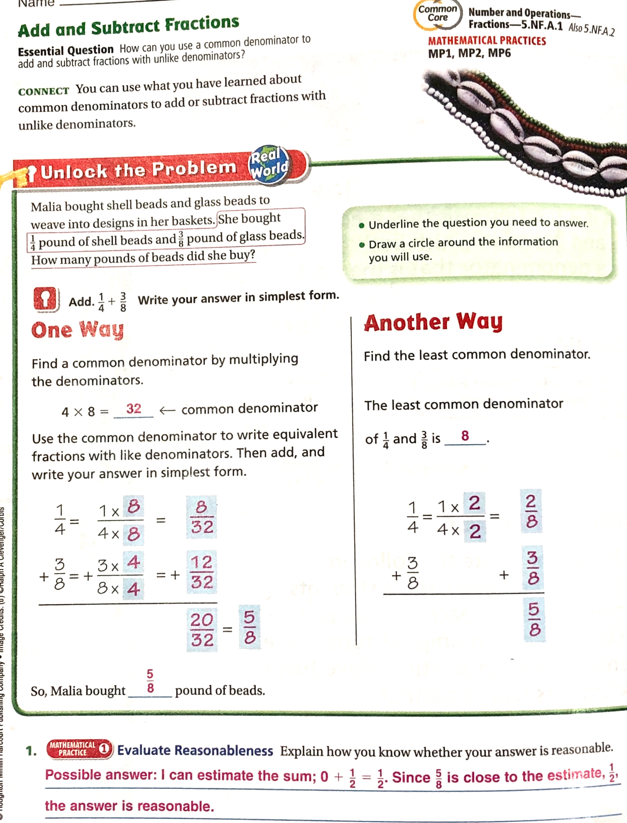
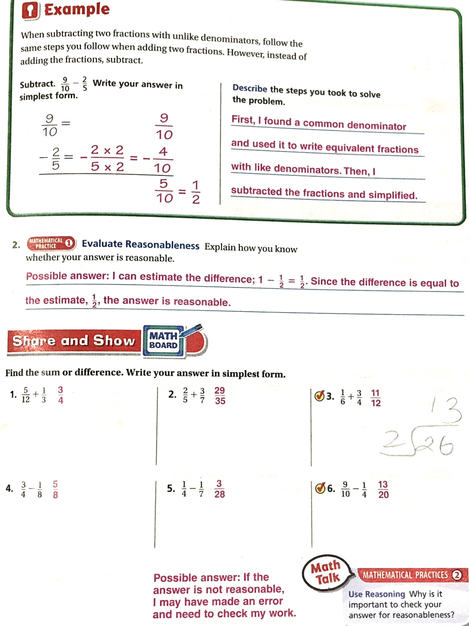
Number 1 has been done for you. Use this as an example for question’s 2-9.
#1. 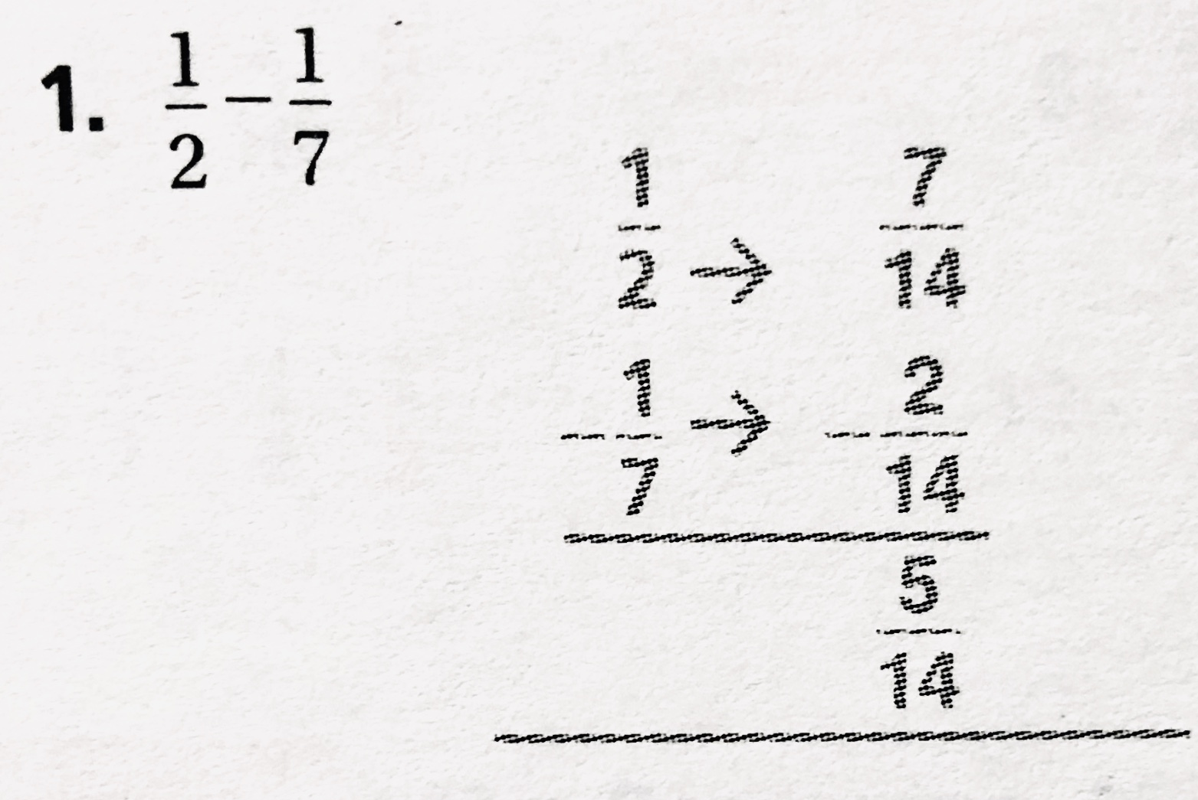

For #’s questions 10-12:
Try your best on these 3 problems (#10, #11, and #12). Use the mini-lesson on adding and subtracting above to help you out, if you need it.
__________________________________________________________________________________________
Third subject: Science
(“Tools are for the birds! Scientists find another type of bird using tools”) Newsela article
*** FOR MODIFICATIONS FOR RESOURCE AND 504:***
PLEASE REFER BACK AND FOLLOW DAY 1’S OUTLINE TO VIEW THE MODIFICATIONS THAT YOU SHOULD FOLLOW.
They vary if you are:
- Doing this assignment on a computer, laptop, or tablet.
- Doing this assignment from the Printed Packet.
** Please choose the modification that best fits what you are working off of. **
If you are doing this assignment with the “Printed Packet” that your parent had picked up from the school, please read below.
Since there are 4 questions, you need to answer 2 questions (you choose them), PLUS 1 more questions of your choice. That’s a total of 3 questions that you have to complete for:
“Tools are for the birds! Scientists find another type of bird using tools”
______________________________________________________________________________
Fourth subject: Social Studies
“Time Machine (1773): The Boston Tea Party” Newsela article.
*** FOR MODIFICATIONS FOR RESOURCE AND 504:***
PLEASE REFER BACK AND FOLLOW DAY 1’S OUTLINE TO VIEW THE MODIFICATIONS THAT YOU SHOULD FOLLOW.
They vary if you are:
- Doing this assignment on a computer, laptop, or tablet.
- Doing this assignment from the Printed Packet.
** Please choose the modification that best fits what you are working off of. **
If you are doing this assignment with the “Printed Packet” that your parent had picked up from the school, please read below.

Since there are 8 questions, you need to answer 4 questions (you choose them), PLUS 2 more questions of your choice. That’s a total of 6 questions that you have to complete for: “Time Machine (1773): The Boston Tea Party”

