**Ms. Sondej’s students, please take a second to review your modifications.**

PLEASE REFER BACK AND FOLLOW DAY 1’S OUTLINE TO CHANGE YOUR LEVELS.
If you have any questions, please email me at: Esondej@gboe.org
_____________________________________________________________________________
Day 5:
First Subject: ELA (Language Arts and Reading)
Definitions/Vocab that you may need for ReadWorks article, “Healing Paws”:
Volunteer- is a person who does something, especially helping other people, willingly and without being forced or paid to do it.
Command- is an authoritative direction or instruction to do something. ; a demand.
Veterinarian- a person relating to, practicing, or being the science and art of prevention, cure, or alleviation of disease and injury in animals and especially domestic animals. ; a person qualified and authorized to practice veterinary medicine.
Theme/Main Idea- Also referred to as a main idea, a theme is the subject explored in a piece of writing. All literary works have a theme. It is what a piece of writing is about.
*Answer all questions directly on the “Packet”, if you’ve picked up the hard copies at school.*
*If you are doing them off of the computer because you DID NOT pick up your packet, you need to transfer your answers into a new notebook.*
For question #5, remember to use RACE when writing your answer!
Example for question #5: “I think that the stand/stay position is the hardest thing for a dog to learn because…”
(Make sure that you use evidence from the text to support your answer.)
______________________________________________________________________________
Second subject: Multiplying Decimals
*** Remember to that you’re multiplying decimals just as they were WHOLE NUMBERS!! ***
*** Count the decimal places after the step ABOVE!! ***
*** Please feel free to use your Multiplication Chart (Graphic Organizer) to help you! ***
SEE “Multiplying Decimals” Charts Below:
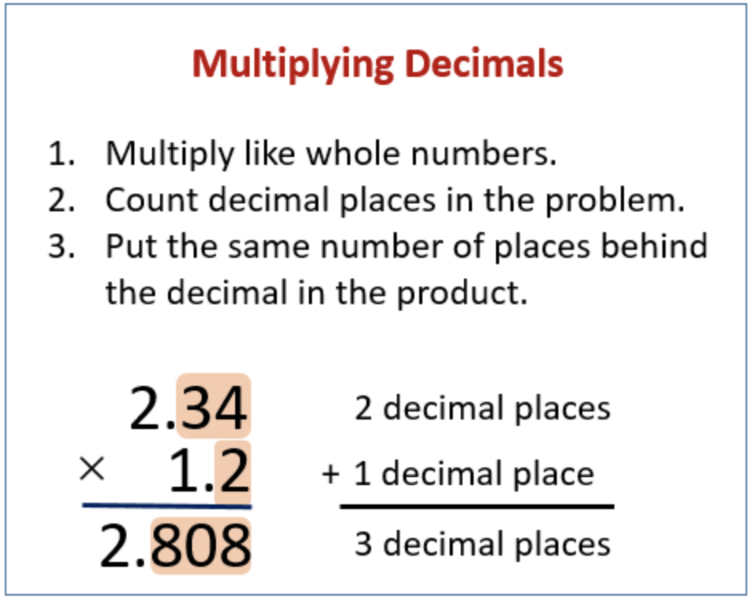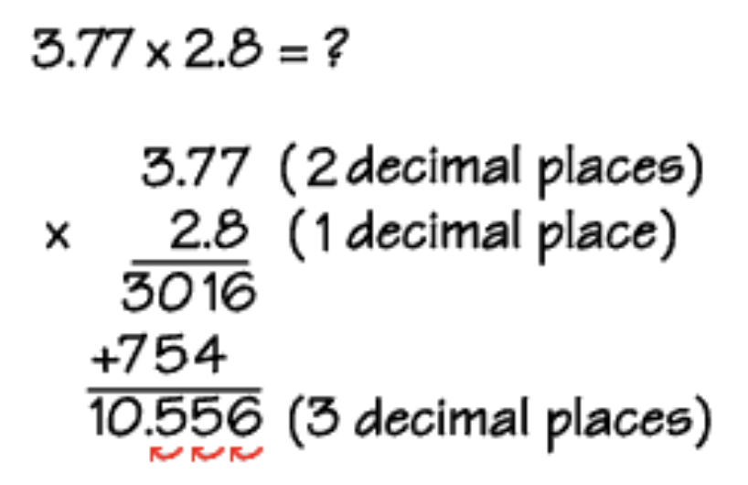
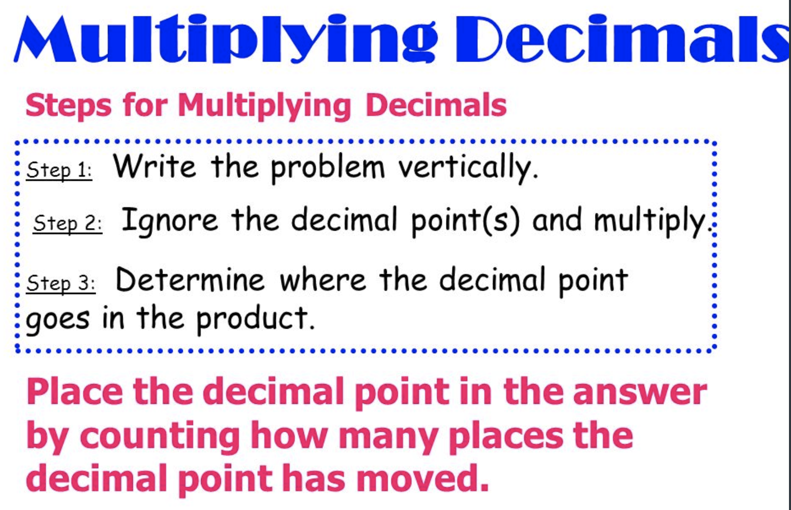

I’ve also included a mini-lesson on multiplying decimals as well, just in case you need a refresher. : )
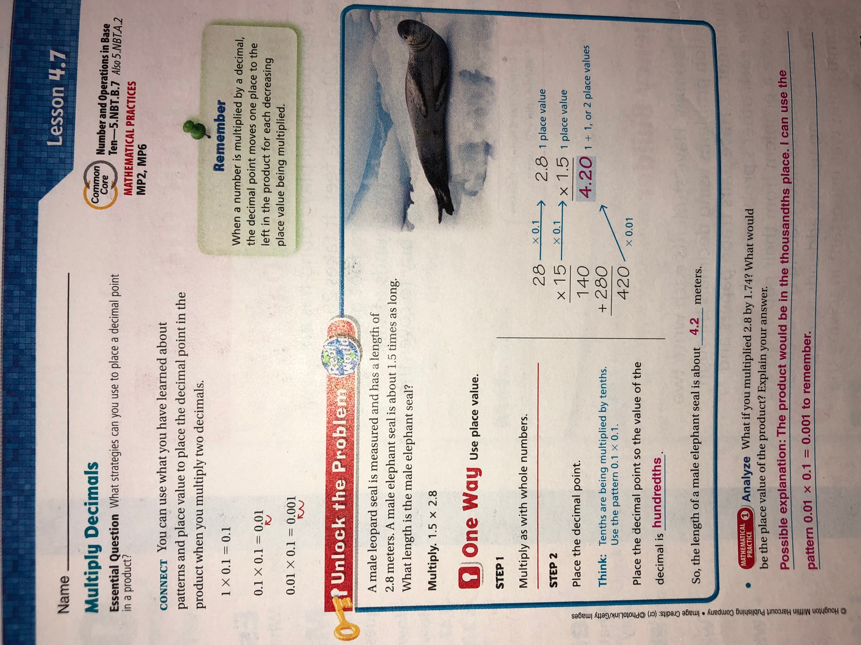
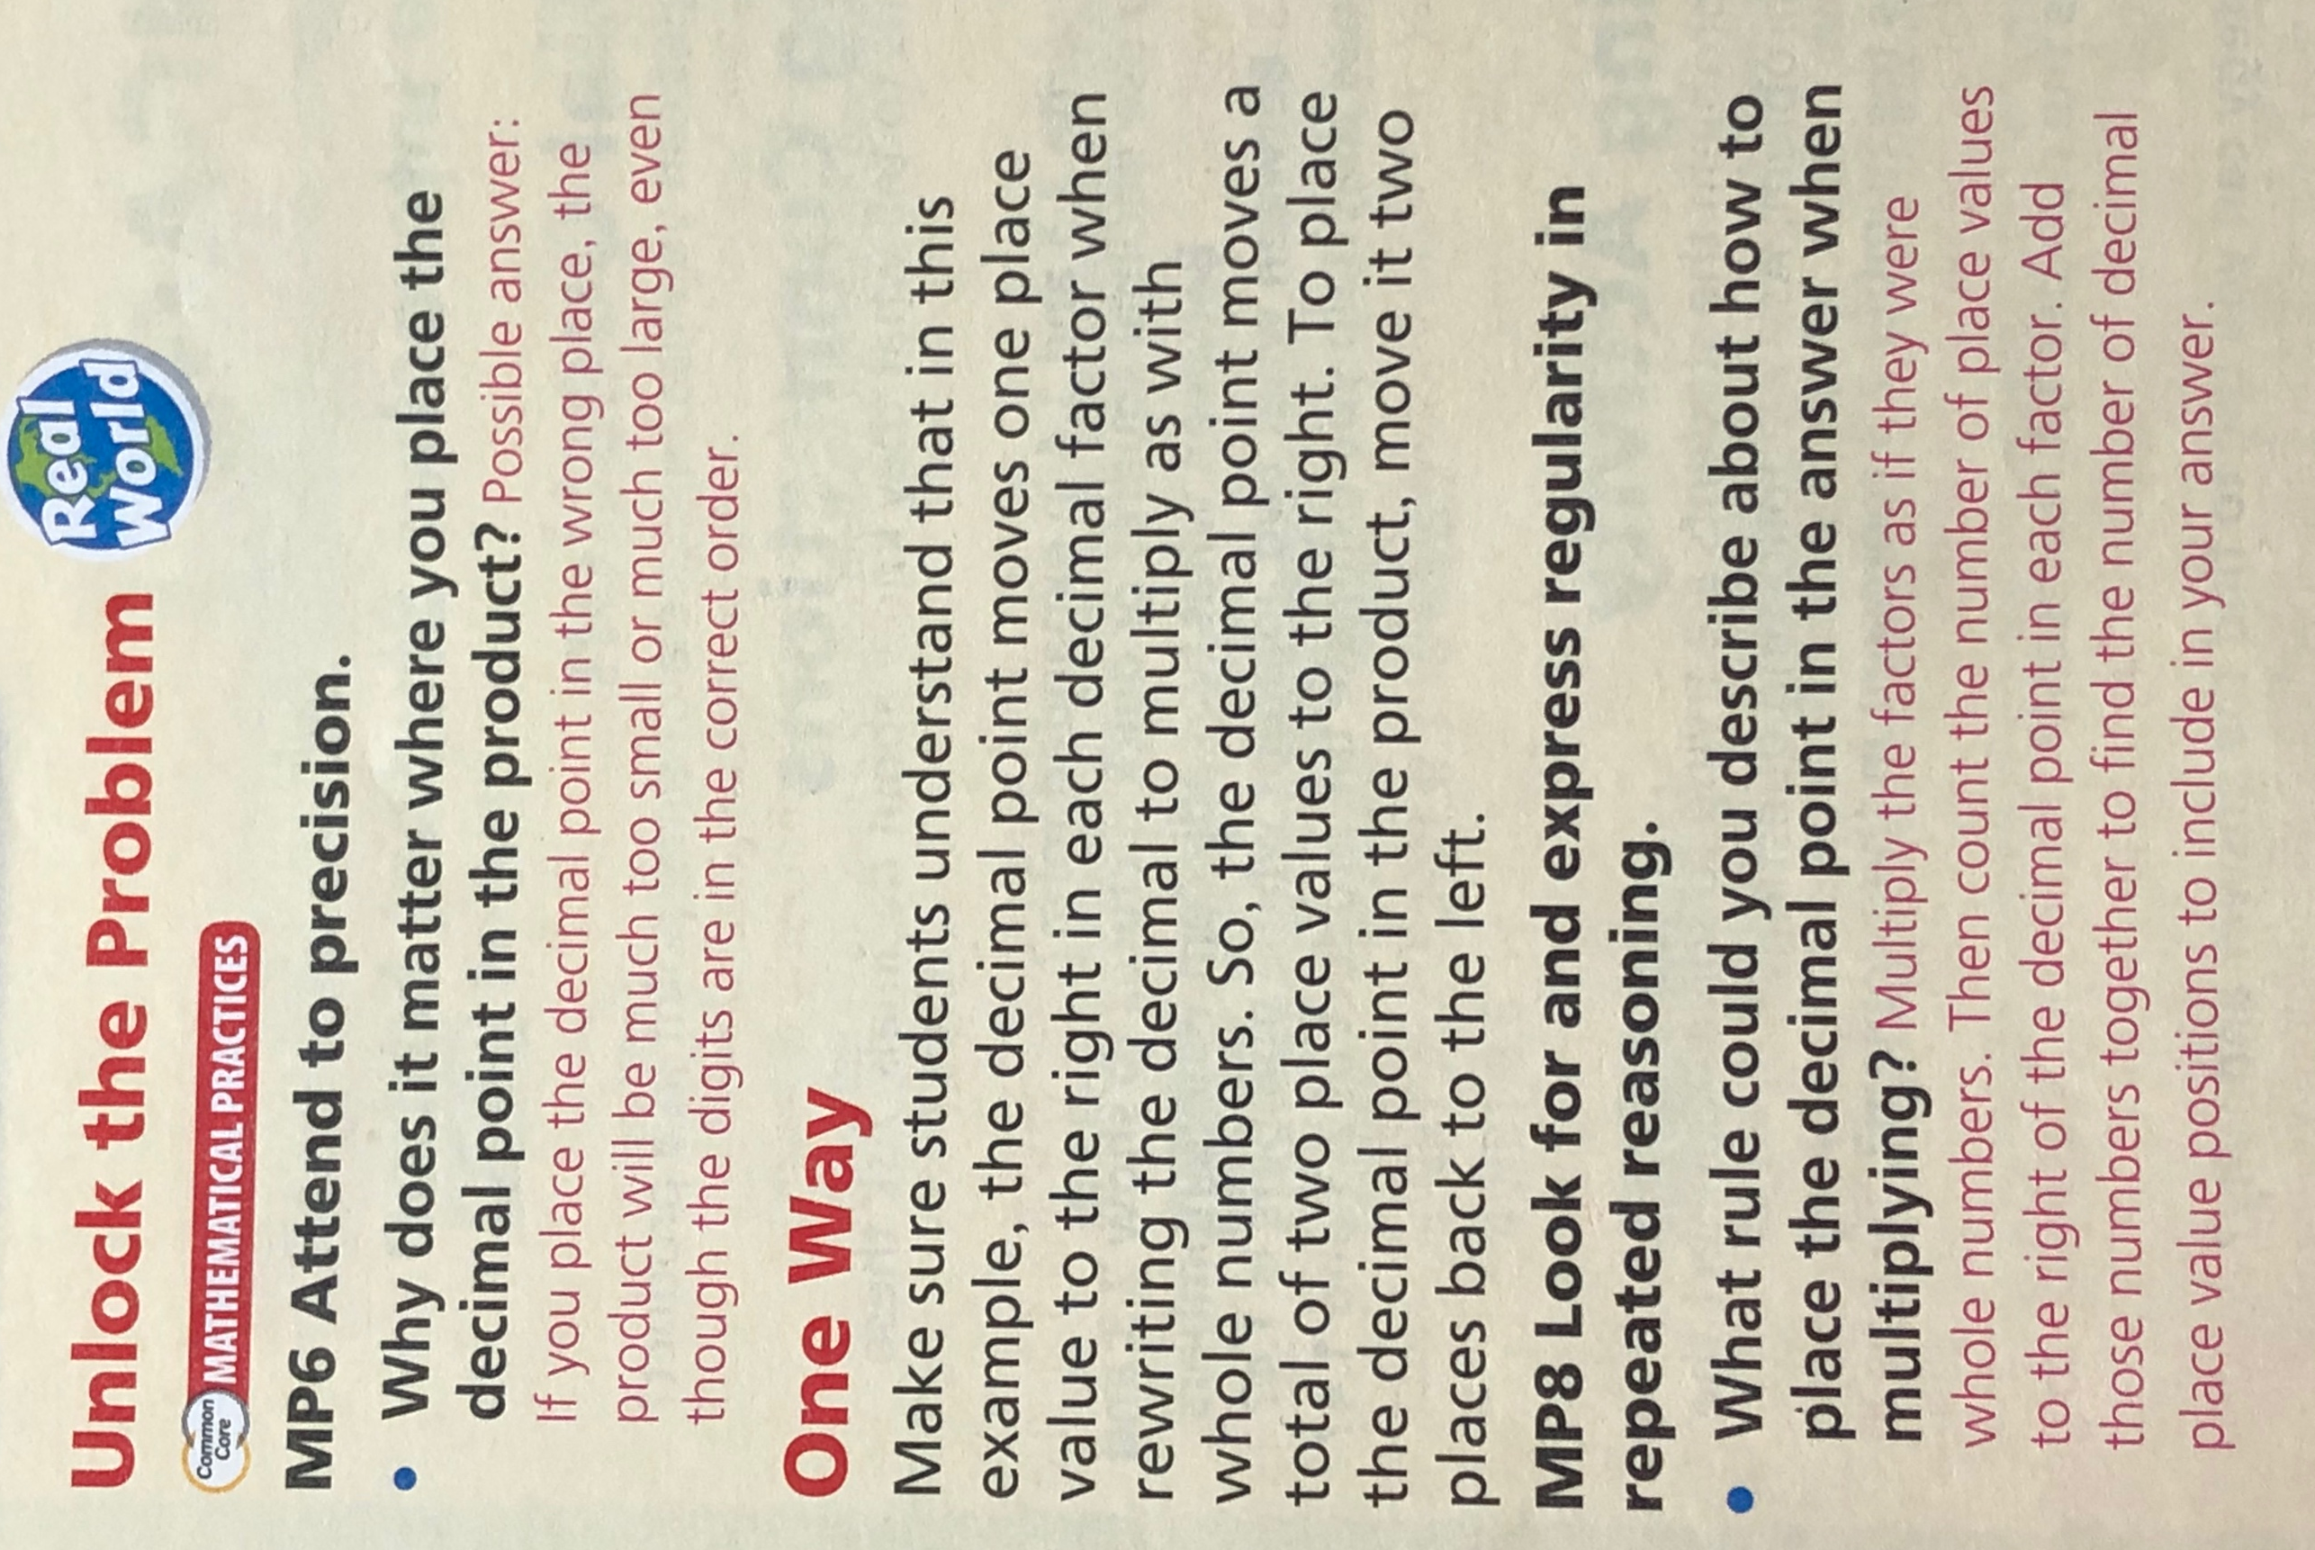
Number 1 has been done for you. Use this as an example for question’s 2-6.
#1.

For #’s 7 - 10:
*** Remember to set your problems up verticality when they are set up horizontally! ***
I did number 7 for you. Please use it as an example for question’s 8-10.
(Look at next page for #7…)
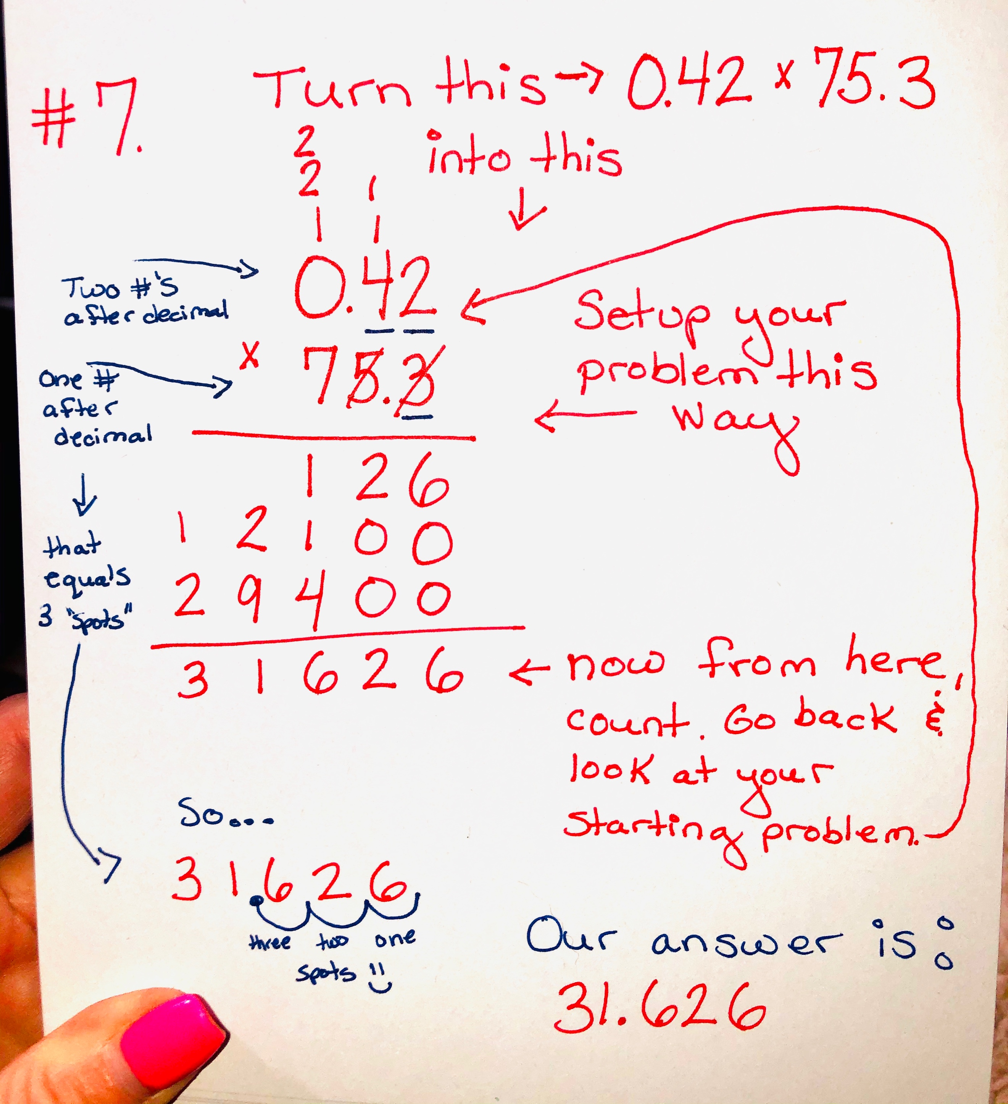

For Problem Solving questions #11 and 12, please refer back to the mini-lesson 4.7 that’s posted ABOVE.
(The male leopard seal and male elephant seal one.)
*** Remember to set your problems up verticality when they are set up horizontally! ***

For #13: It says…
WRITE: Write a word problem that includes multiplying decimals. Explain how you know where to place the decimal in the product.

This is my example for #13. Do not copy. Please come up with your own.
ANSWER:
Juan worked 30.75 hours this week.
Here’s how I solved this problem: (See picture attached on next page)
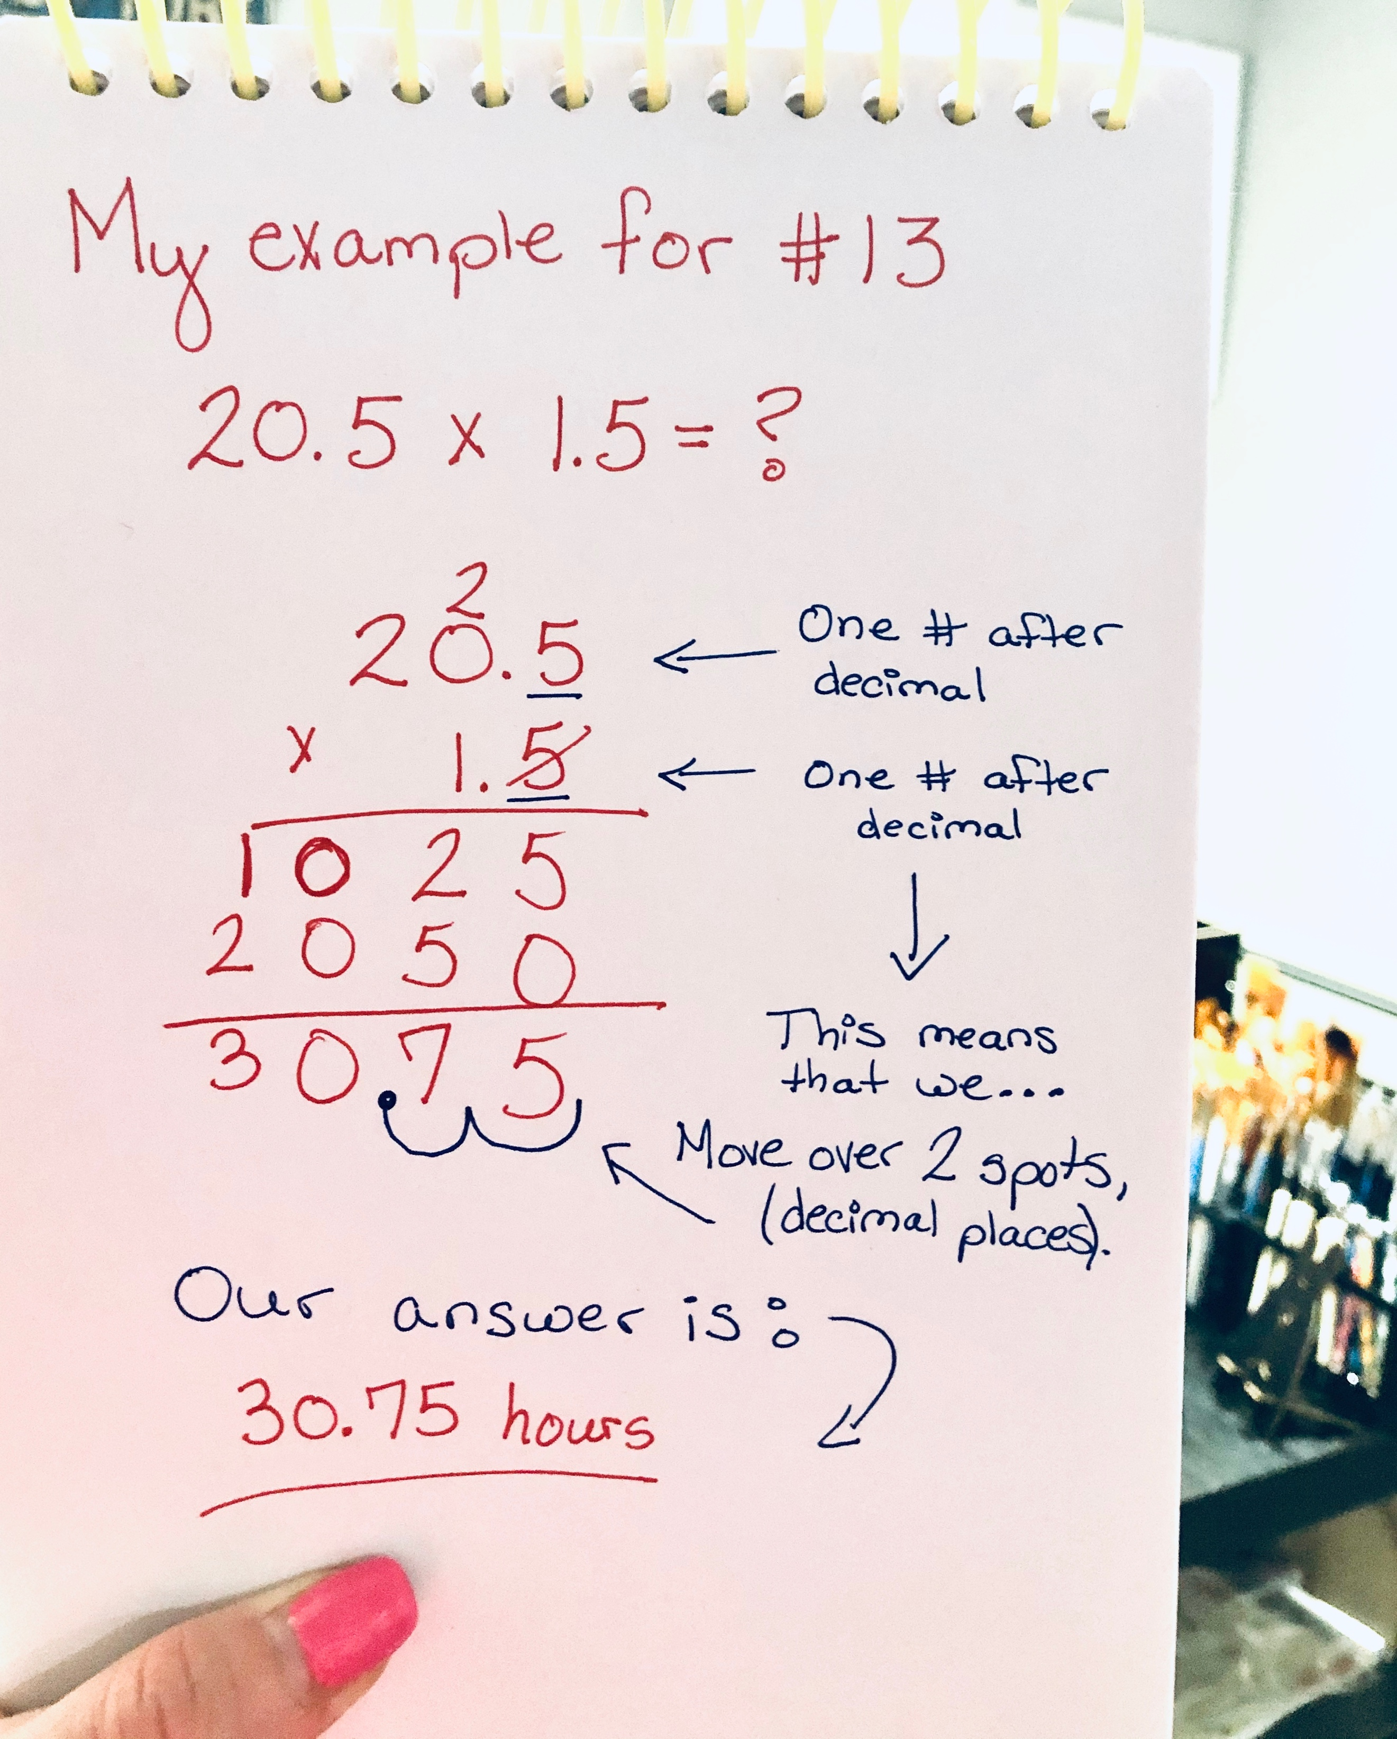
____________________________________________________________________________
Third subject: Science
(“An overview of saturated solutions”) Newsela article
*** FOR MODIFICATIONS FOR RESOURCE AND 504:***
PLEASE REFER BACK AND FOLLOW DAY 1’S OUTLINE TO VIEW THE MODIFICATIONS THAT YOU SHOULD FOLLOW.
They vary if you are:
- Doing this assignment on a computer, laptop, or tablet.
- Doing this assignment from the Printed Packet.
** Please choose the modification that best fits what you are working off of. **
If you are doing this assignment with the “Printed Packet” that your parent had picked up from the school, please read below.
Since there are 4 questions, you need to answer 2 questions (you choose them), PLUS 1 more questions of your choice. That’s a total of 3 questions that you have to complete for:
“An overview of saturated solutions”
______________________________________________________________________________

Fourth subject: Social Studies
“Time Machine (1770): The Boston Massacre” Newsela article.
*** FOR MODIFICATIONS FOR RESOURCE AND 504:***
PLEASE REFER BACK AND FOLLOW DAY 1’S OUTLINE TO VIEW THE MODIFICATIONS THAT YOU SHOULD FOLLOW.
They vary if you are:
- Doing this assignment on a computer, laptop, or tablet.
- Doing this assignment from the Printed Packet.
** Please choose the modification that best fits what you are working off of. **
If you are doing this assignment with the “Printed Packet” that your parent had picked up from the school, please read below.

Since there are 8 questions, you need to answer 4 questions (you choose them), PLUS 2 more questions of your choice. That’s a total of 6 questions that you have to complete for: “Time Machine (1770): The Boston Massacre”

