**Ms. Sondej’s students, please take a second to review your modifications.**

PLEASE REFER BACK AND FOLLOW DAY 1’S OUTLINE TO CHANGE YOUR LEVELS.
If you have any questions, please email me at: Esondej@gboe.org
_____________________________________________________________________________
Day 8 (March 25th, 2020):
First Subject: ELA (Language Arts and Reading)
Definitions/Vocab that you may need for ReadWorks article, “Stopping the Spread”:
Malaria- is a dangerous disease cause by a germ spread through mosquito bites. If left untreated, malaria can be fatal.
Pale- is used to describe a person's face or skin if it has less color than usual, for example when the person is or sick or frightened, or if it has less color than people generally have.
Lethargic- having little energy; feeling sluggish, drowsy; feeling unwilling and unable to do anything.
Fatal- a fatal illness, accident, etc. causes death. ; Causing or capable of causing death; mortal; deadly.
Prompt- ready in action; quick to act as occasion demands. ; Done quickly and without delay, or (of a person) acting quickly or arriving at the arranged time.
Fortunately- happening because of good luck.
Clinic- an establishment or hospital department where outpatients are given medical treatment or advice, especially of a specialist nature.
Insecticides- is a chemical used to kill mosquitoes and other insects.
Eradicated- destroy completely; put an end to.
Eliminated- completely remove or get rid of (something).
Drawbacks- a disadvantage or the negative part of a situation.
Colleagues- one of a group of people who work together. ; is someone you work with at your job.
Optimistic- hoping or believing that good things will happen in the future.
Dramatic- very sudden or noticeable, or full of action and excitement. ; Striking or exaggerated.
______________________________________________________________________________
*Answer all questions directly on the “Packet”, if you’ve picked up the hard copies at school.*
*If you are doing them off of the computer because you DID NOT pick up your packet, you need to transfer your answers into a new notebook.*
For question #5, remember to use RACE when writing your answer!
Example for question #5:
“To help Africa fight malaria, the preventive actions I think should be tried first are ___________ because…
To help Africa fight malaria, the preventive actions I think should be tried second are ___________ because…
To help Africa fight malaria, the preventive actions I think should be tried third are ___________ because…”
** (Make sure that you explain WHY!!) **
(Make sure that you use evidence from the text to support your answer.)
______________________________________________________________________________

Second subject: Math (Add and Subtract Fractions)
*Similar to yesterday’s lesson (Day 7 – March 24th) It’s the same content*
SEE “Adding and Subtracting Fractions” Charts Below:
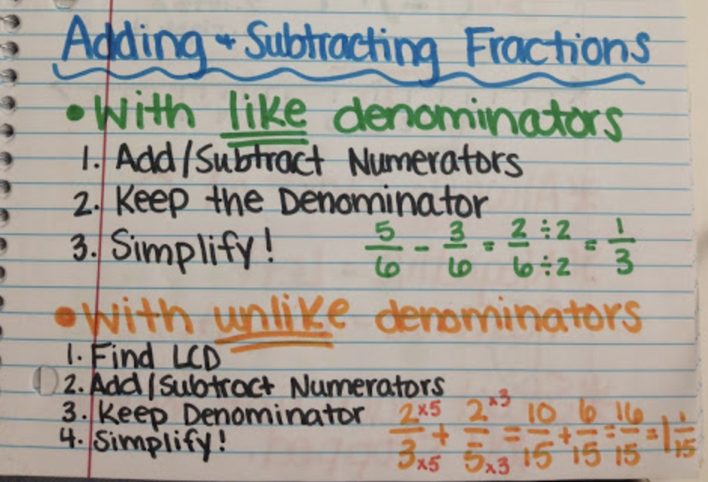
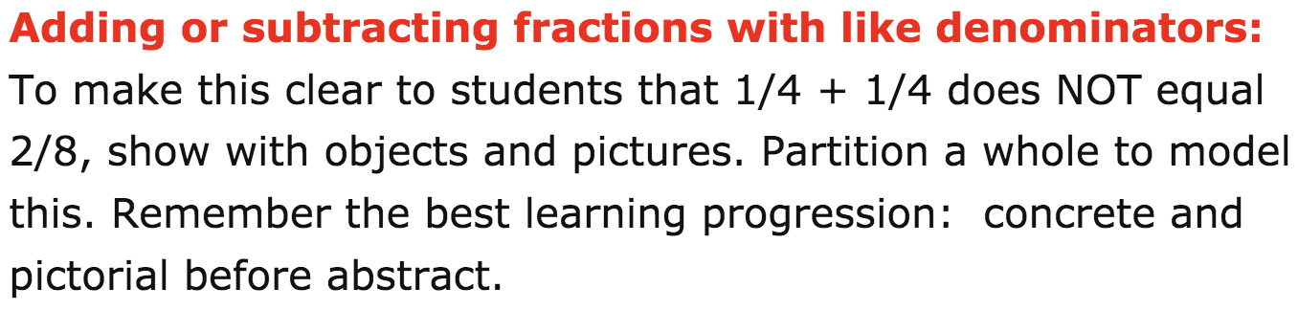
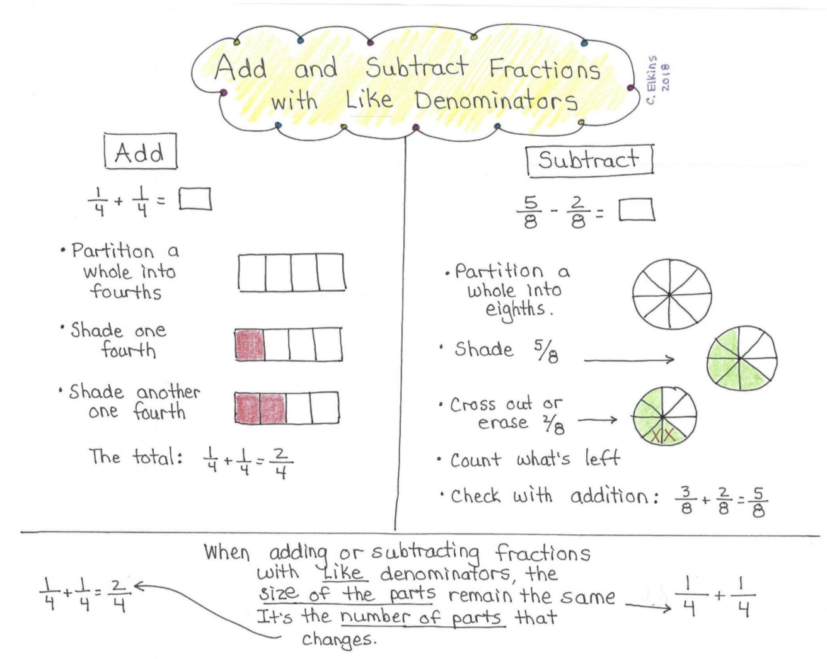_________________________________
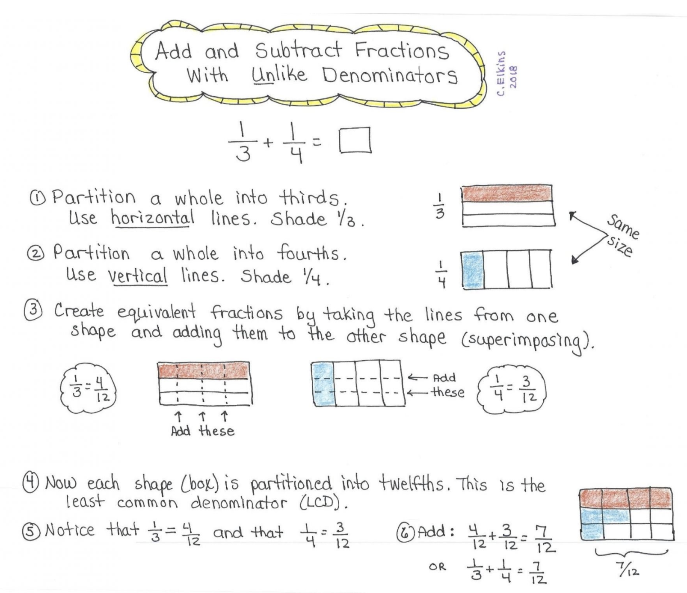
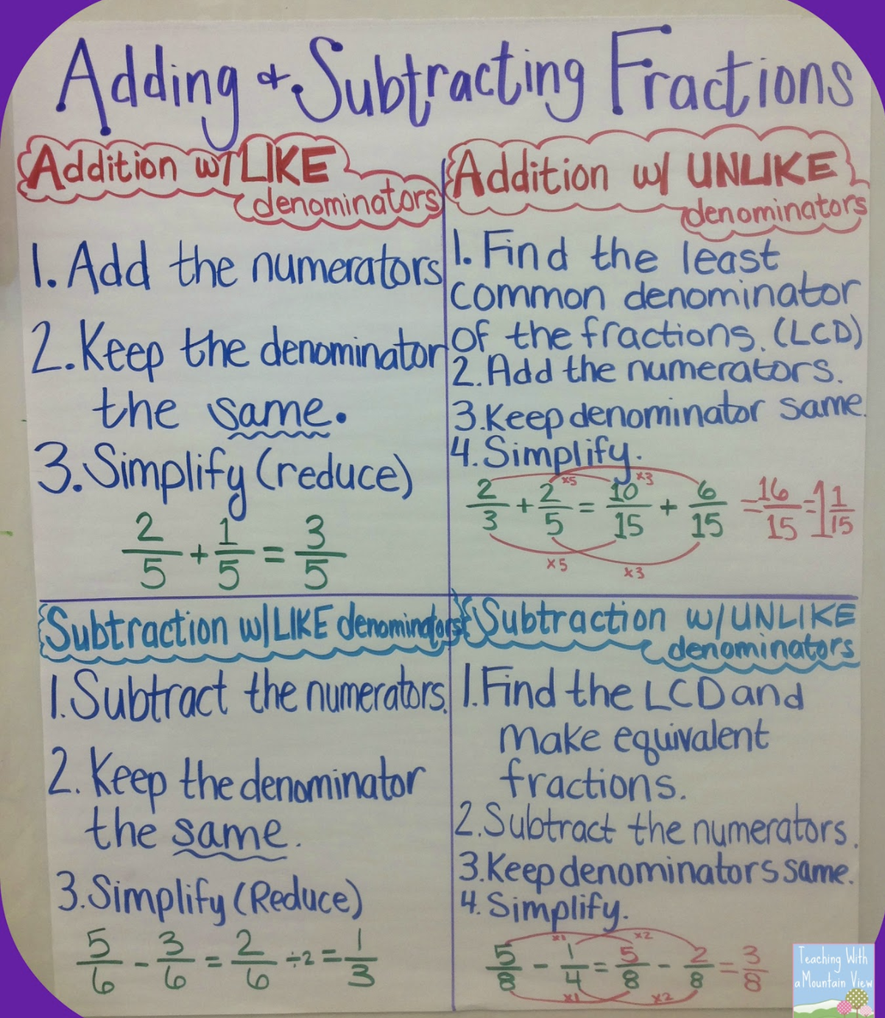
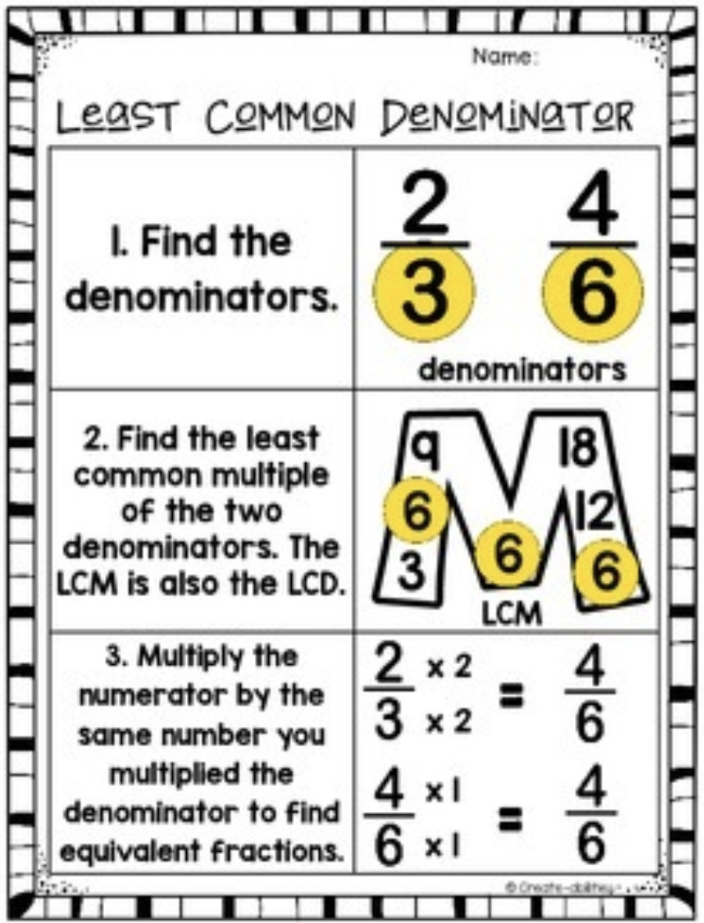
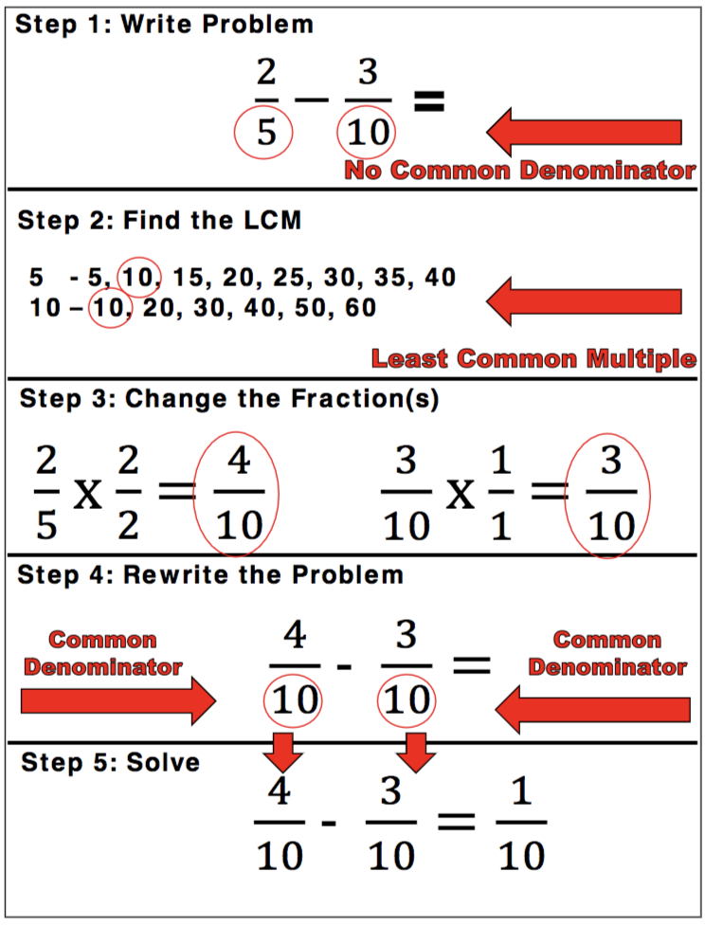
I’ve also included a mini-lesson on add and subtracting fractions as well, just in case you need a refresher. : )
*Similar to yesterday’s lesson (Day 7 – March 24th) It’s the same content*

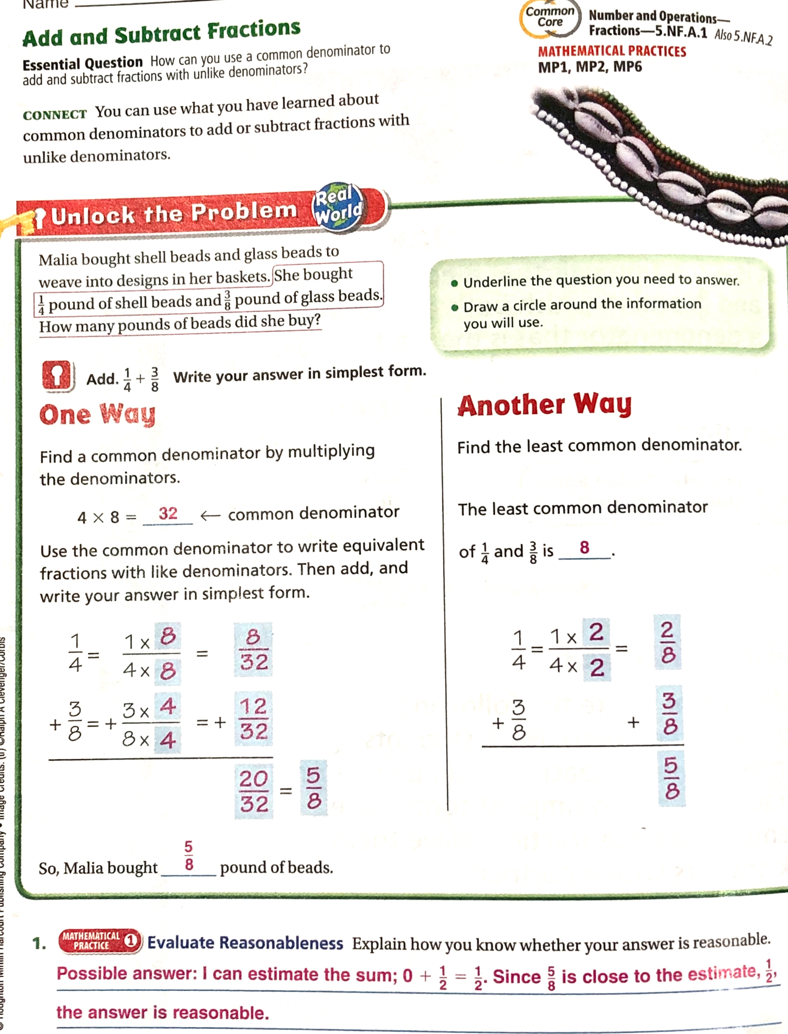
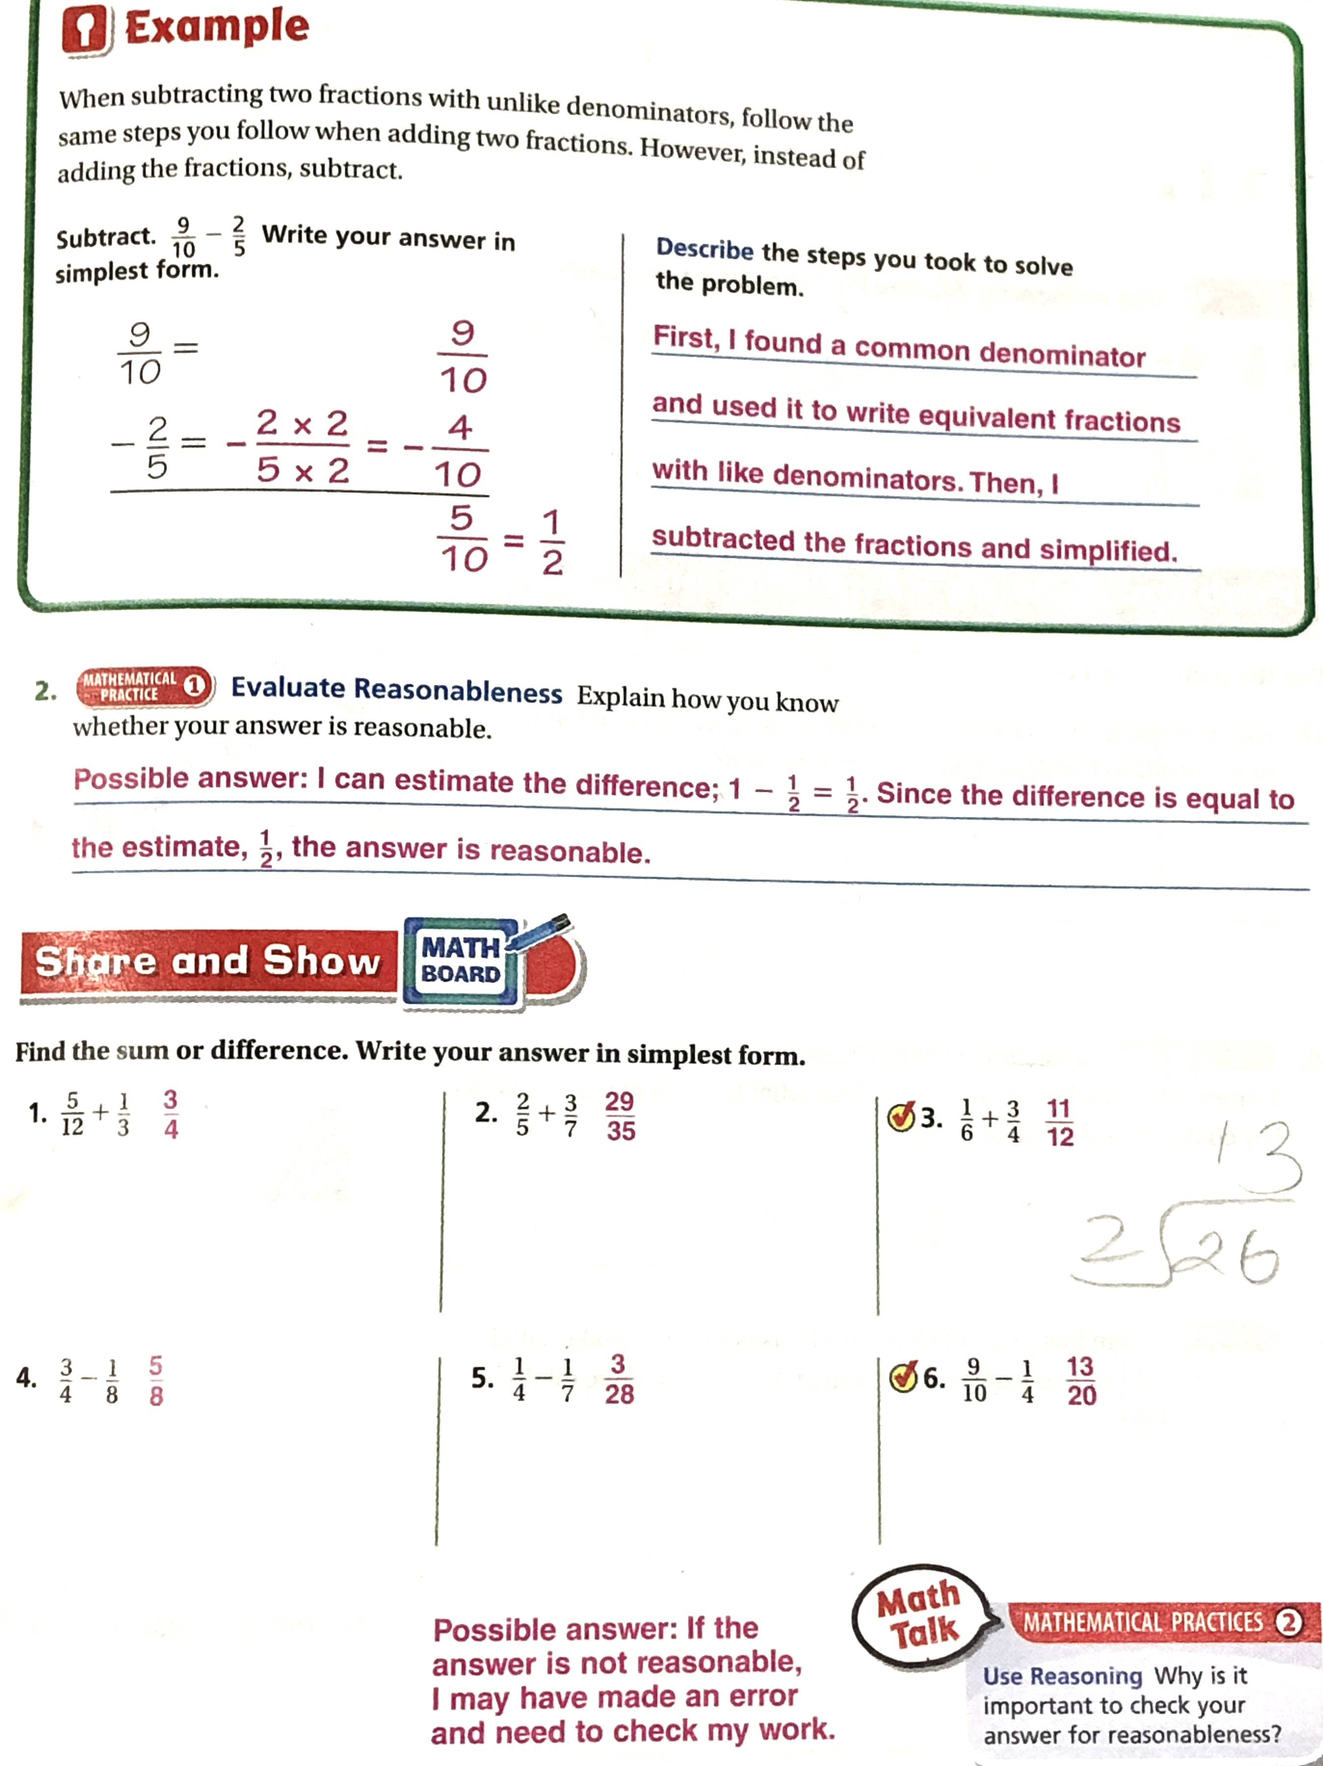
Number 1 has been done for you. Use this example to help you with question’s 2 - 5.
# 1.
For # 6:
Try your best on #6. Use theses mini-lessons below question #6 to help you out, if you need it.
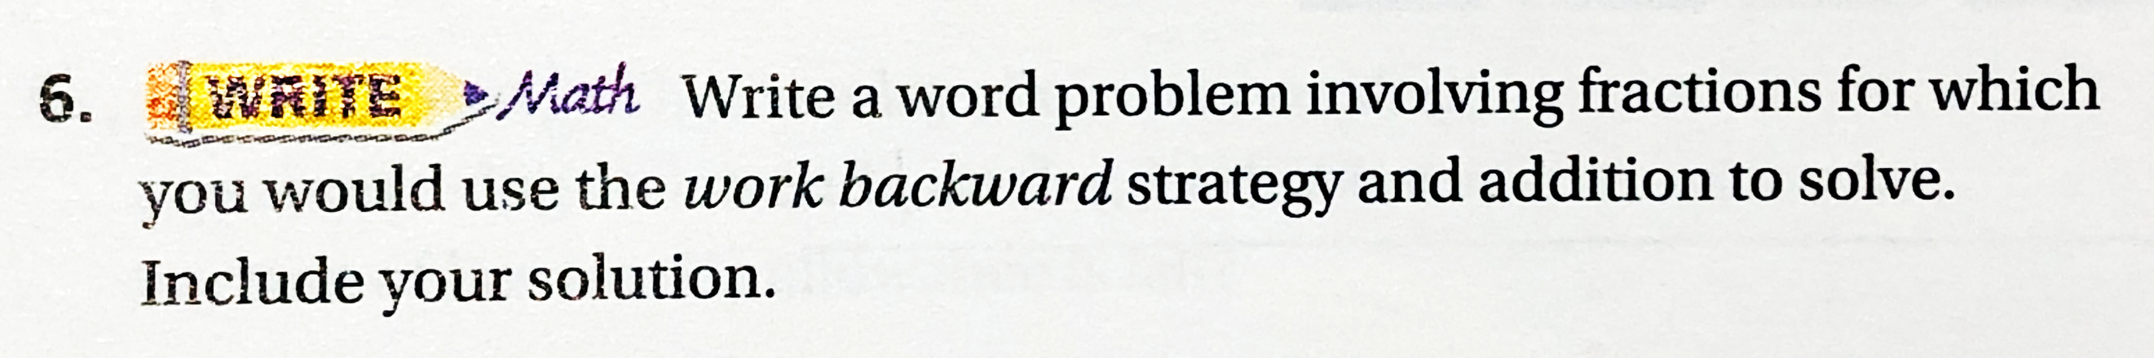

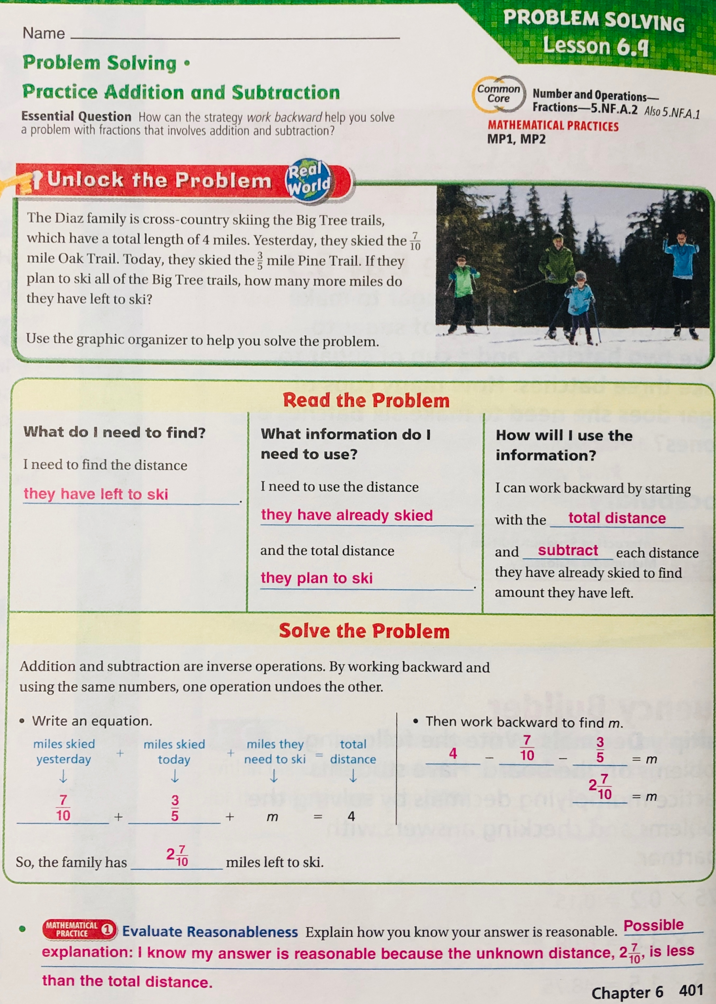

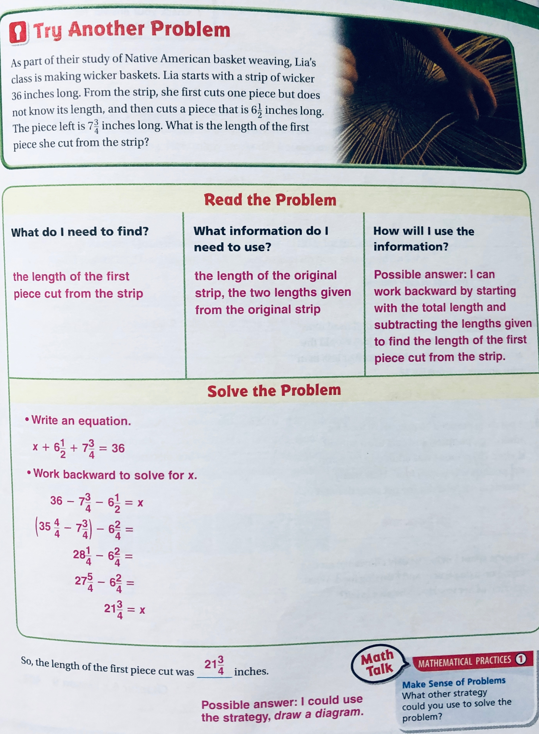

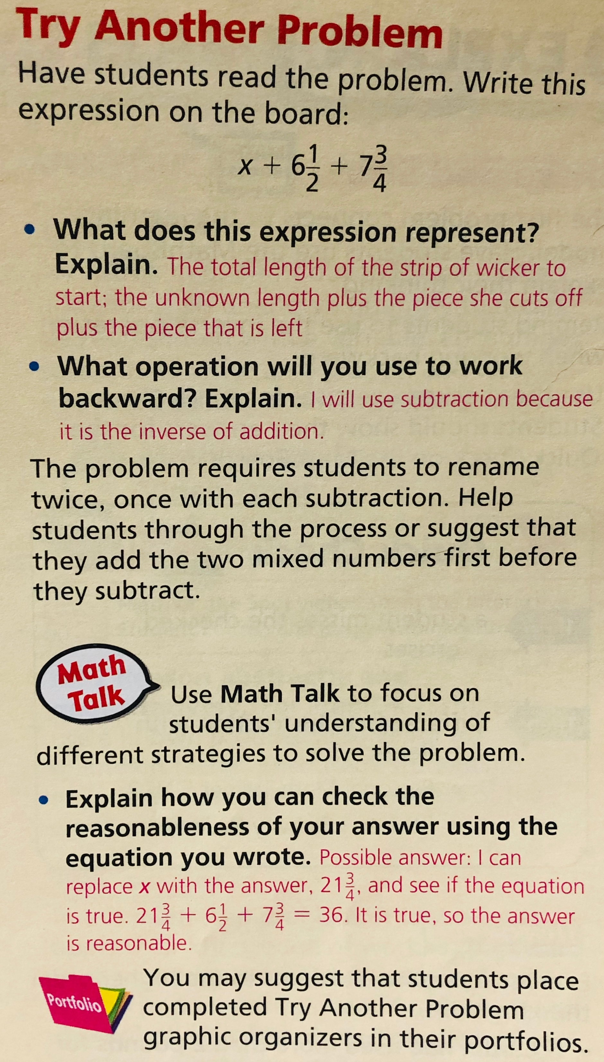
__________________________________________________________________________________________
Third subject: Science
(“What is heat energy?”) Newsela article
*** FOR MODIFICATIONS FOR RESOURCE AND 504:***
PLEASE REFER BACK AND FOLLOW DAY 1’S OUTLINE TO VIEW THE MODIFICATIONS THAT YOU SHOULD FOLLOW.
They vary if you are:
- Doing this assignment on a computer, laptop, or tablet.
- Doing this assignment from the Printed Packet.
** Please choose the modification that best fits what you are working off of. **
If you are doing this assignment with the “Printed Packet” that your parent had picked up from the school, please read below.
Since there are 4 questions, you need to answer 2 questions (you choose them), PLUS 1 more questions of your choice. That’s a total of 3 questions that you have to complete for:
“What is heat energy?”
__________________________________________________________________________________________
__________________________________________________________________________________________
Fourth subject: Social Studies
“The American Revolution: Political Upheaval Led to U.S. Independence” Newsela article.
*** FOR MODIFICATIONS FOR RESOURCE AND 504:***
PLEASE REFER BACK AND FOLLOW DAY 1’S OUTLINE TO VIEW THE MODIFICATIONS THAT YOU SHOULD FOLLOW.
They vary if you are:
- Doing this assignment on a computer, laptop, or tablet.
- Doing this assignment from the Printed Packet.
** Please choose the modification that best fits what you are working off of. **
If you are doing this assignment with the “Printed Packet” that your parent had picked up from the school, please read below.

Since there are 4 questions, you need to answer 2 questions (you choose them), PLUS 1 more questions of your choice. That’s a total of 3 questions that you have to complete for: “The American Revolution: Political Upheaval Led to U.S. Independence”

