**Ms. Sondej’s students, please take a second to review your modifications.**

PLEASE REFER BACK AND FOLLOW DAY 1’S OUTLINE TO CHANGE YOUR LEVELS.
If you have any questions, please email me at: Esondej@gboe.org
_____________________________________________________________________________
Day 2:
First Subject: ELA (Language Arts and Reading)
Definitions/Vocab that you may need for ReadWorks article, “Welcome Home”:
Tarmac- is an area with a surface made of tarmac, (crushed stones mixed with tar) especially the area from which planes take off at an airport.
Drone- a low continuous humming sound.
Blur- a quick movement; or quickly occurring; or without warning.
*Answer all questions directly on the “Packet”, if you have picked up the hard copies at school.*
*If you are doing them off of the computer because you DID NOT pick up your packet, you need to transfer your answers into a new notebook.*
For question #6 and #7, remember to use RACE when writing your answer!

Example for #6: “The people at the airport were honoring the soldiers coming home by…”

Example for #7: “Amy, Joel, and their dad felt ______________ while waiting at the airport…”
(Make sure that you use evidence from the text to support your answer.)
______________________________________________________________________________
Second subject: Math (Evaluate Numerical Expressions)
Use: PEMDAS - an order of operation (set of rules).
Start with: parenthesis first, then exponents, then multiplication, then division, then addition, then lastly do subtraction.
SEE “(P)EMDAS Chart’s” Below:
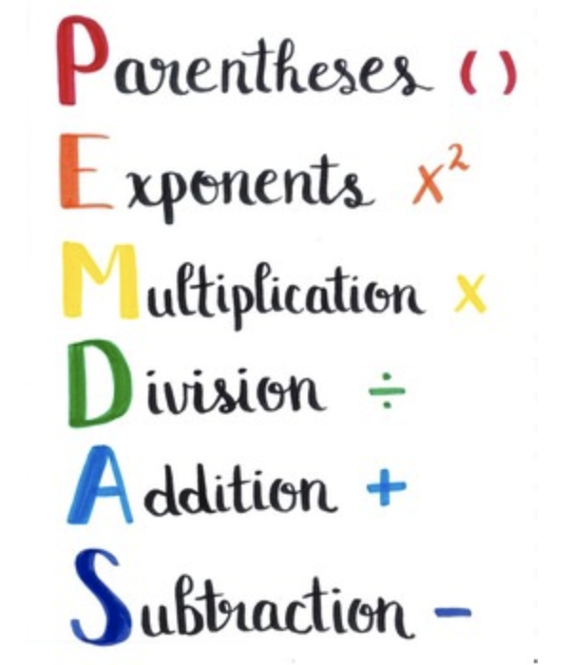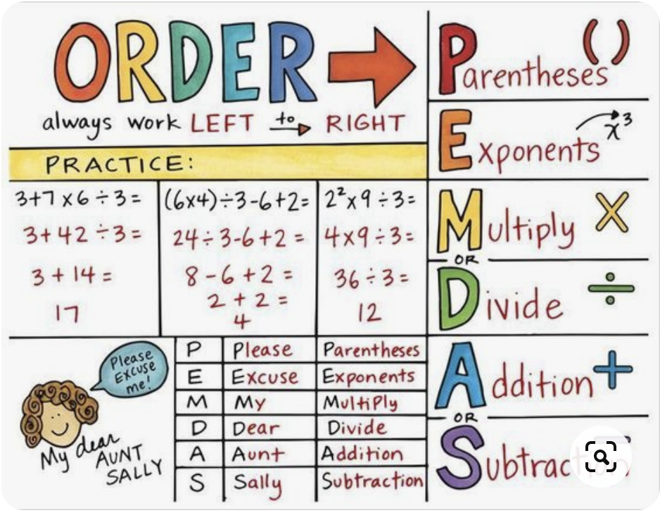

Number 1 has been done for you. Use this as an example for question’s 2-4.
- 25 x 5 - 41
120 - 41
= 79
_____________________________________________________________________________
I did #5 for you (see below):
Please use it as a reference for #6 and #7:
Rewrite the expression with parentheses to equal the given value.
#5. 3 x 4 - 1 + 2
Value: 11
Answer is: 3 x (4 - 1) + 2
______________________________________________________________________________
Here’s the work to show how I got the answer:
3 x 4 - 1 + 2
Value: 11 (The value is what the answer needs to equal/come to)
Step 1: Add parentheses to 4 - 1
3 x (4 - 1) + 2
Step 2: Start with the parentheses (4 -1)
3 x (4 - 1) + 2
3 x (3) + 2
Step 3: Do the multiplication
3 x (3) + 2
9 + 2
Step 4: Add
9 + 2
9 + 2 = 11
11 is your “value”/answer
_____________________________________________________________________________
For #10 (WRITE), I have an example done for you.
Review it and then come up with your own.
10. Give two examples that show how using parentheses can change the order in which operations are performed in an expression.
This is my example for #10. Do not copy. Please come up with your own.
I Only did ONE example, you need to do TWO.
Example 1: (8+10) - 6 x 2 AND 8 + (10 - 6 ) x 2

Example 1: (8+10) - 6 x 2 AND 8 + (10 - 6 ) x 2
To solve: (8+10) - 6 x 2
Step 1: Solve what’s in the parentheses first (ADD)
(8+10) - 6 x 2
18 - 6 x 2
Step 2: Do the multiplication
18 - 6 x 2
18 - 12
Step 3: Subtract
18 - 12
18 - 12 = 6
_____________________________________________________________________________

Now I’m using the same exact #’s, but using parentheses to show you how they can change the order.

To solve: 8 + (10 - 6) x 2
Step 1: Solve what’s in the parentheses first (Subtract)
8 + (10 - 6) x 2
8 + 4 x 12
Step 2: Do the multiplication
8 + 4 x 12
8 + 48
Step 3: ADD
8 + 48
= 56
______________________________________________________________________________
Third subject: Science
(Planetary motion: The idea that began a science revolution) Newsela article
*** FOR MODIFICATIONS FOR RESOURCE AND 504:***
PLEASE REFER BACK AND FOLLOW DAY 1’S OUTLINE TO VIEW THE MODIFICATIONS THAT YOU SHOULD FOLLOW.
They vary if you are:
- Doing this assignment on a computer, laptop, or tablet.
- Doing this assignment from the Printed Packet.
** Please choose the modification that best fits what you are working off of. **
If you are doing this assignment with the “Printed Packet” that your parent had picked up from the school, please read below.
Since there are 4 questions, you need to answer 2 questions (you choose them), PLUS 1 more questions of your choice. That’s a total of 3 questions that you have to complete for “Planetary motion: The idea that began a science revolution.”
______________________________________________________________________________
Fourth subject: Social Studies (“The New England colonies and Native Americans”) Newsela article.
*** FOR MODIFICATIONS FOR RESOURCE AND 504:***
PLEASE REFER BACK AND FOLLOW DAY 1’S OUTLINE TO VIEW THE MODIFICATIONS THAT YOU SHOULD FOLLOW.
They vary if you are:
- Doing this assignment on a computer, laptop, or tablet.
- Doing this assignment from the Printed Packet.
** Please choose the modification that best fits what you are working off of. **
If you are doing this assignment with the “Printed Packet” that your parent had picked up from the school, please read below.
Since there are 4 questions, you need to answer 2 questions (you choose them), PLUS 1 more questions of your choice. That’s a total of 3 questions that you have to complete for “The New England colonies and Native Americans.”

